[**Development**](https://github.com/SuryaMahesh789/Warehouse-Management-System---Angular)

**Login Page**

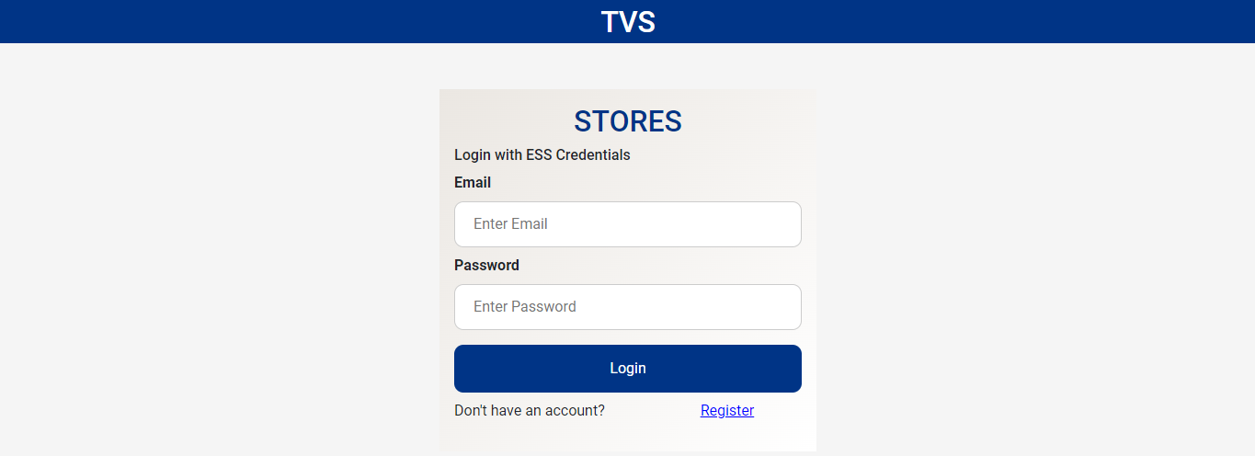

**Register Page**

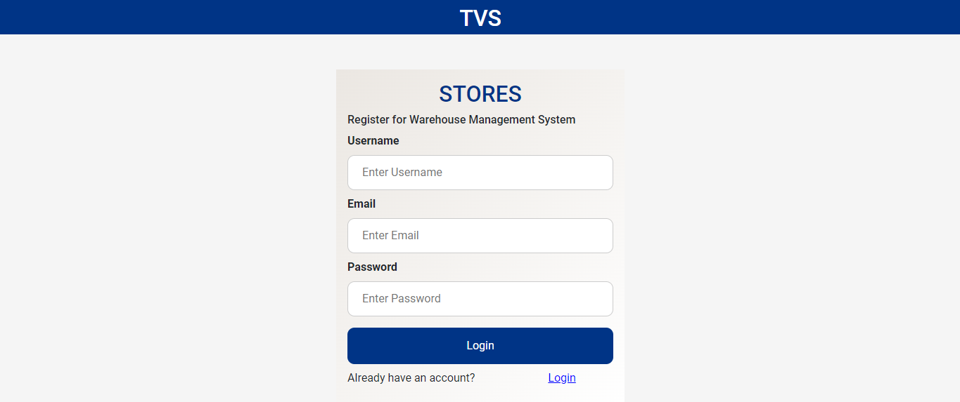

**Dashboard**

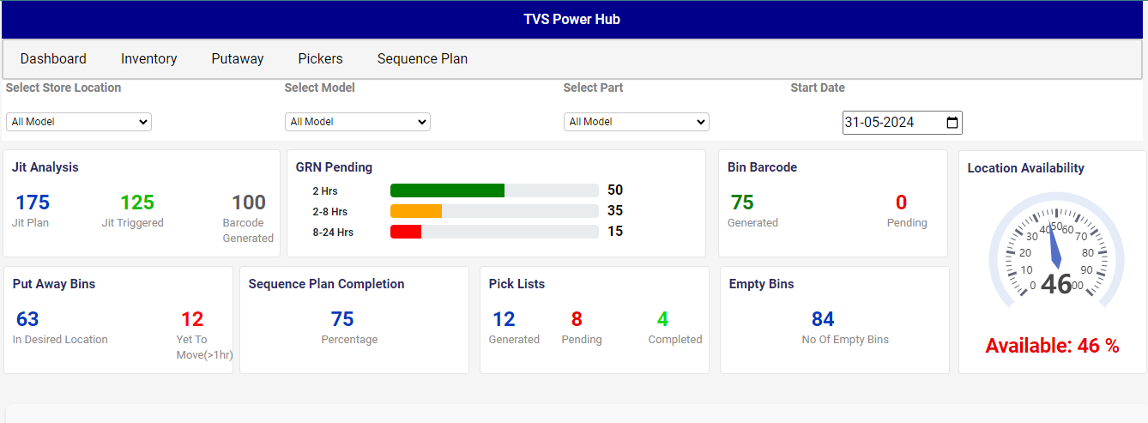

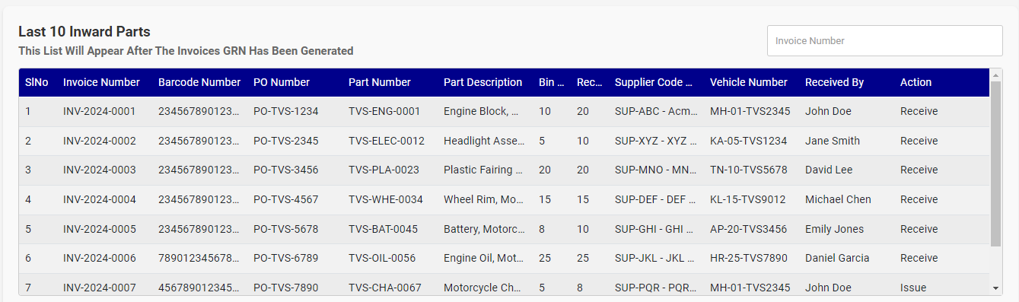

**Inventory**

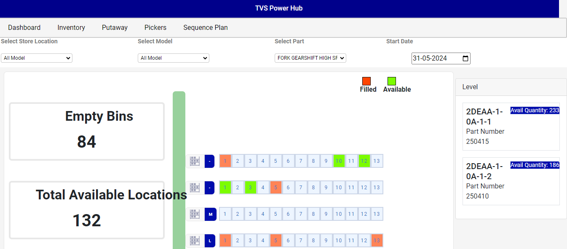

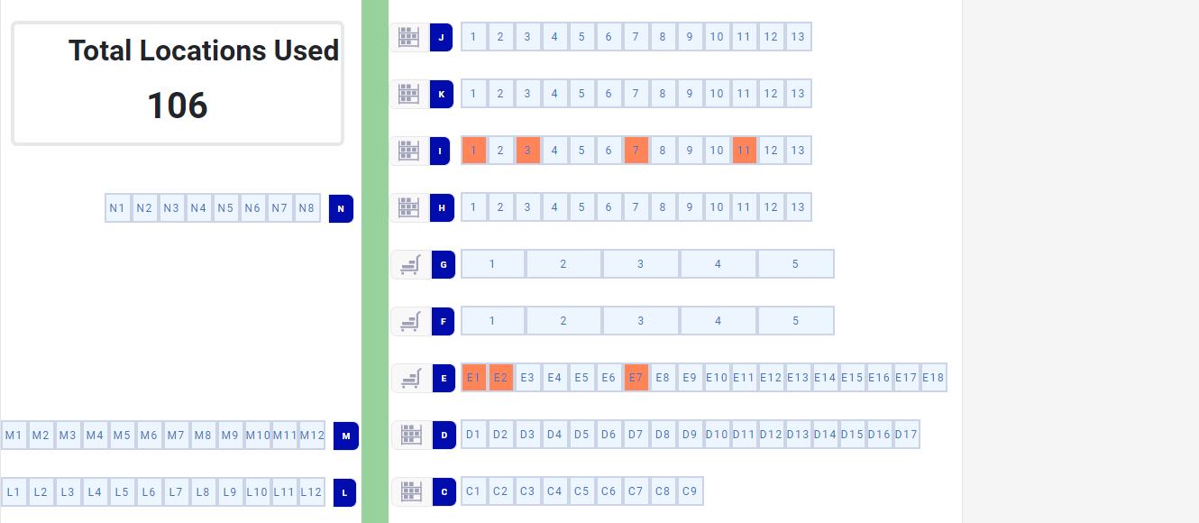

**Sequence Plan**

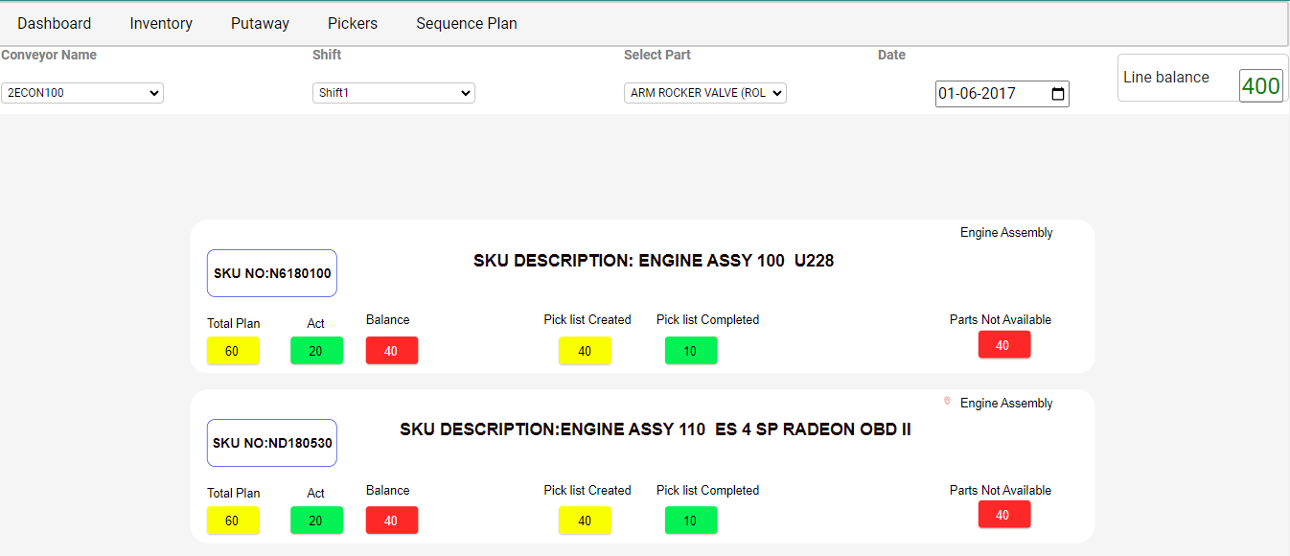

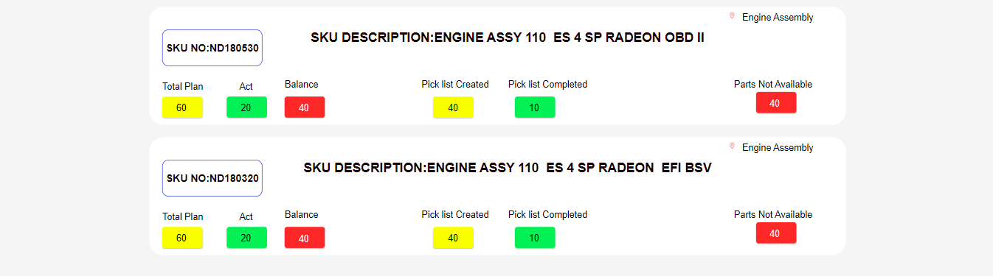

**Putaway**

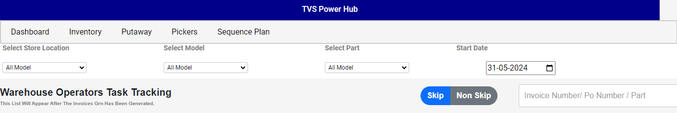

**Pickers**

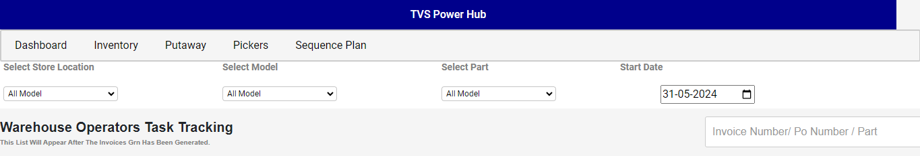

[**Design**](https://xd.adobe.com/view/0f5f4efe-eeb6-4ca5-b98f-80043c900b8c-5a0c/screen/21616181-095d-49fb-8b8e-f34cc1aca793?fullscreen)

**Login**

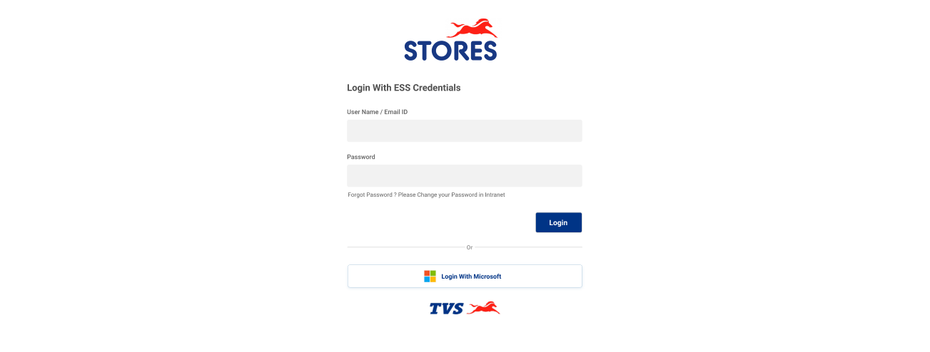

**Dashboard**

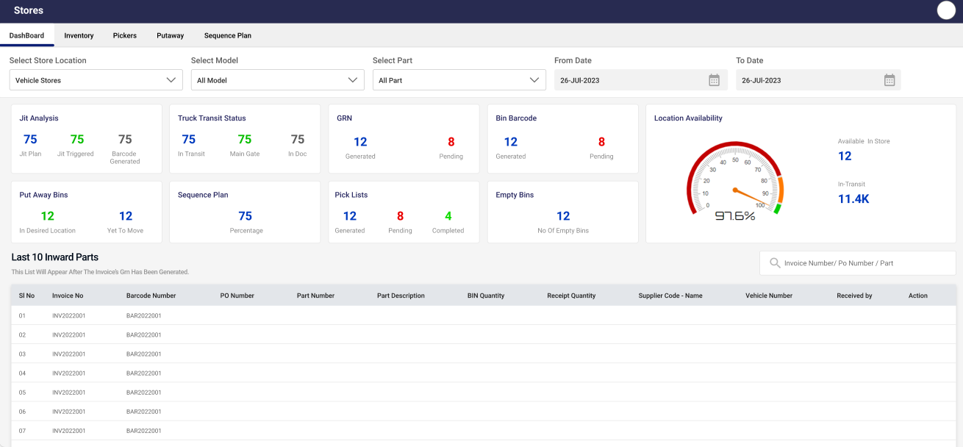

**Inventory**

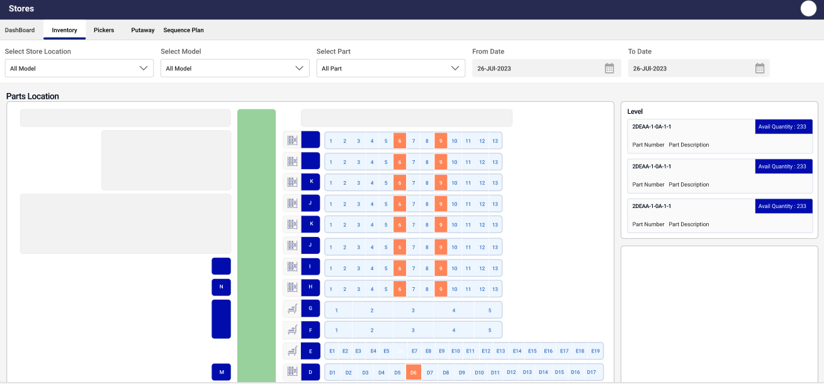



**Sequence Plan**

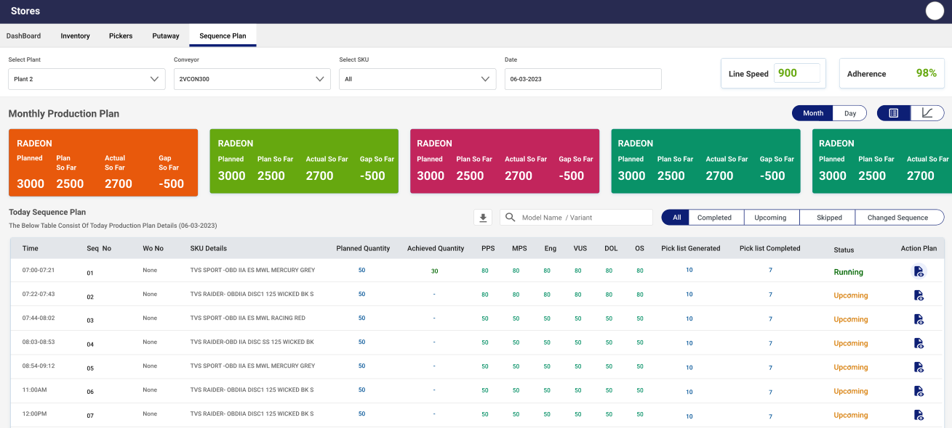

**Pickers**

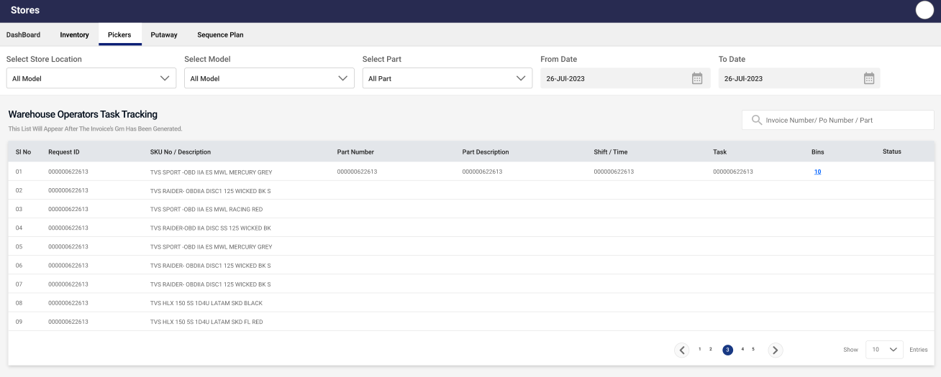

**Putaway**

